The COVID-19 pandemic in the United States
Abstract: The study investigated the evolution of COVID-19 mortality rates in the United States across different phases of the pandemic with the aim of understanding how the virulence of the virus changed over time. Utilizing R programming, we analyzed weekly COVID-19 mortality data from 2020 to 2024 to identify six distinct phases of the pandemic. Through visualization of weekly death counts and mortality rates, significant differences were observed among states, with New York and California experiencing higher mortality rates during the initial phase, and Texas and Florida struggling in later phases. The analysis also indicated that the virulence of COVID-19 decreased with the widespread adoption of vaccines but increased during the emergence of new variants such as Delta and Omicron. These findings provide crucial insights into the dynamic nature of COVID-19 and highlight the importance of targeted interventions to address regional disparities. The study concludes that a comprehensive understanding of the pandemic's spatiotemporal dynamics is essential for developing effective public health strategies, as well as for formulating appropriate interventions, optimizing resource allocation, and proactive planning to mitigate the impact of emerging infectious diseases.
1 Introduction
The COVID-19 pandemic, which emerged at the beginning of 2020, has had a profound and far-reaching impact on global health, the economy, and the social fabric. As one of the nations hit hardest by the outbreak, the United States has witnessed significant variations in the spread and severity of the virus across its states. These disparities in the pandemic's trajectory present a unique opportunity to delve into the dynamic nature of COVID-19 and its implications for public health^{[1]}. It is of paramount importance to comprehend how mortality rates fluctuate across different stages and how the virulence of the virus evolves over time, as this knowledge is crucial for devising effective public health strategies to mitigate the impact of emerging infectious diseases^{[2]}.
This study focuses on the analysis of weekly COVID-19 mortality data spanning from 2020 to 2024, with the aim of identifying the critical phases of the pandemic and evaluating the performance of each state in managing the crisis. By segmenting the pandemic into distinct phases and examining trends in mortality rates, our objective is to provide information that can inform and guide decision-makers and healthcare professionals in making prudent decisions. Furthermore, we have explored how the virulence of COVID-19 has responded to vaccination campaigns and the emergence of new variants, such as Delta and Omicron^{[3, 4]}. The significance of this research lies in its ability to offer a comprehensive understanding of the pandemic's progression and the factors that contribute to its severity^{[5]}. By identifying states at higher risk and understanding the effects of viral mutations, this study can contribute to the development of targeted interventions and the refinement of public health policies. Ultimately, through this analysis, we can gain a deeper insight into the complex dynamics of COVID-19 and provide guidance on solutions for dealing with potential future pandemic crises.
The COVID-19 pandemic has been a global challenge, yet its effects have varied significantly from one region to another. Within the United States, the virus has not spread evenly, with some states experiencing higher infection and mortality rates compared to others. These differences can be attributed to a multitude of factors, including population density, healthcare infrastructure, vaccination rates, and public health policies. By analyzing these variations, we can better understand the factors that contribute to the spread and severity of the virus, as well as the effectiveness of different response strategies. In the ongoing debate regarding the effectiveness of public health measures, such as lockdowns, mask mandates, and vaccination campaigns, this study is particularly relevant. By examining the temporal and spatial patterns of the pandemic, we can offer evidence-based insights into which strategies are most effective and where additional resources are needed. Moreover, understanding the evolution of viral virulence can aid in guiding the development of new vaccines and treatments, as well as in future pandemic preparedness efforts^{[6]}. This research is not only a reflection of our commitment to learning from the past but also a proactive step towards building a more resilient healthcare system capable of facing future challenges.
2 Methods

This study utilized R programming to analyze publicly available COVID-19 mortality data, covering the period from January 2020 to December 2024. The dataset^{[11]} encompasses weekly COVID-19 death records and mortality rates for each state, along with variables such as weekend dates and state-specific demographic information. The primary focus of the analysis was to identify trends in mortality rates and to assess the performance of states across different stages of the pandemic.
During the data preprocessing phase, stringent measures were taken to ensure the accuracy and consistency of the data. This included a thorough cleaning of the dataset, removing any entries that were missing or inconsistent, which is crucial as the quality of the data directly impacts the reliability of the analytical results. To facilitate time series analysis, weekend dates were converted into a unified, standardized date format. This step was essential for subsequent data analysis as it allowed us to correctly align data points within their respective timeframes, enabling a more precise analysis of trends. For data visualization, we utilized the ggplot2 package in R, a widely used plotting tool capable of creating high-quality graphics that aid in more intuitive data comprehension.
Mortality rates, serving as a key indicator of the severity of the pandemic, were calculated for each state, and corresponding time series plots were created to compare the performance of different regions. This not only helped us identify the areas most affected but also revealed disparities in the progression of the pandemic across various regions.
In order to segment the pandemic period from January 2020 to December 2024 into distinct waves, we have constructed a phase diagram of the pandemic. This chart encapsulates the progression of COVID-19 mortality rates in the United States from 2020 to 2024, offering a clear and concise overview of the impact of the pandemic over time. We initially conducted an in-depth analysis of the data from January 2020 to December 2024, identifying significant points of change in mortality rates, which often corresponded with the emergence of new variants, increases in vaccination rates, or shifts in public health policies. Using these points of change, we divided the entire pandemic period into several waves, each representing a unique phase of COVID-19 transmission and impact. The chart allows us to distinctly observe the rises and falls in mortality rates and their correlation with different stages of the pandemic. The timeline of these different phases enables us to track the changes in the virus's virulence and the effectiveness of public health interventions. The diagram not only emphasizes the variability in mortality rates across different periods but also serves as evidence of the evolving nature of the pandemic. Furthermore, the diagram is designed to provide comparative analysis, allowing viewers to quickly grasp the differences in the severity of the pandemic across the six phases. The early stages were marked by a rapid increase in mortality rates, which then decreased in the middle stages due to the effective rollout of vaccines. However, with the emergence of new variants, there was a trend of increasing mortality rates. These were eventually brought down by vaccination efforts and the introduction of new treatments. This visual representation is crucial for policymakers and public health officials to assess the effectiveness of past strategies and to plan future public health responses.
After delineating the pandemic into six distinct phases, we calculated the average mortality rate for each state during each phase. This statistical data offers a direct perspective on how the epidemic spread and evolved across different regions, aiding in the evaluation of each state's effectiveness in managing the crisis. The fluctuation trends of data points along the timeline vividly reflect changes in mortality rates, which is crucial for understanding the dynamics of the pandemic. Through this detailed analysis, we have been able to comprehensively grasp the dynamics of the COVID-19 pandemic, including how the virulence of the virus has changed over time and the performance of different states during various phases. This information is essential for formulating effective public health strategies and also provides invaluable guidance for future responses to epidemics.
Furthermore, to provide a more concrete measure of the pandemic's situation in each region, we tallied the number of deaths per state over the course of a week. This statistical data offers a direct view of the spread and impact of the pandemic across different areas and is categorized by phase, which assists in evaluating the effectiveness of each state's response to the pandemic.

3 Results
Mortality rates in each state serve as a key metric for measuring the severity of the pandemic. Based on the data obtained, Figure 1 was created, a time series chart that compares the performance of different regions. This has not only helped us identify the areas most affected but also revealed disparities in the progression of the pandemic across various regions. It is evident that New York and California struggled during the initial stages, while Texas and Florida faced challenges in the later stages.
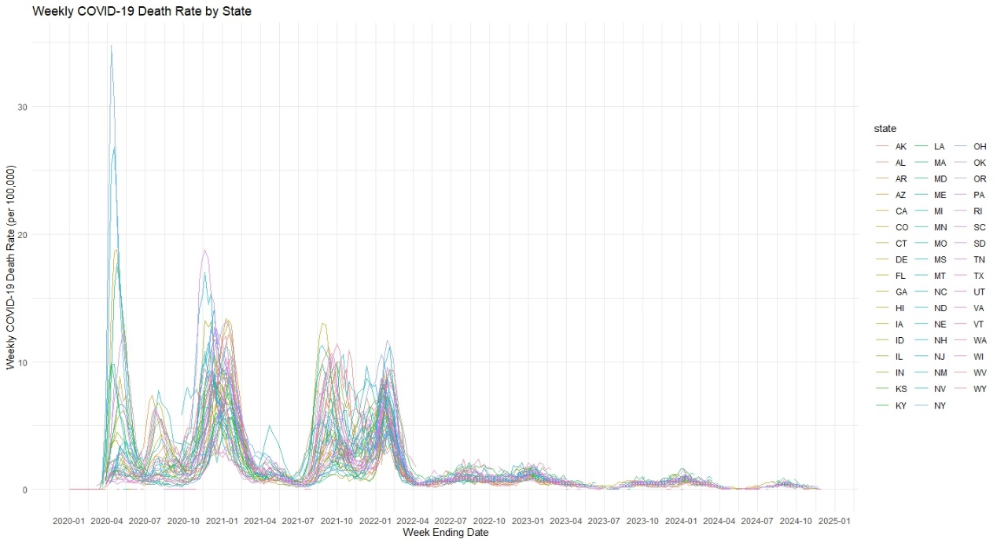
Fig. 1 Weekly COVID-19 death rate by state
To segment the pandemic period into multiple waves, we created Figure 2. By identifying significant points of change in mortality rates, we divided the entire pandemic period into six phases. The dashed vertical lines superimposed on the chart mark the transitions between the six distinct phases of the pandemic, with each phase corresponding to a notable shift in mortality patterns.
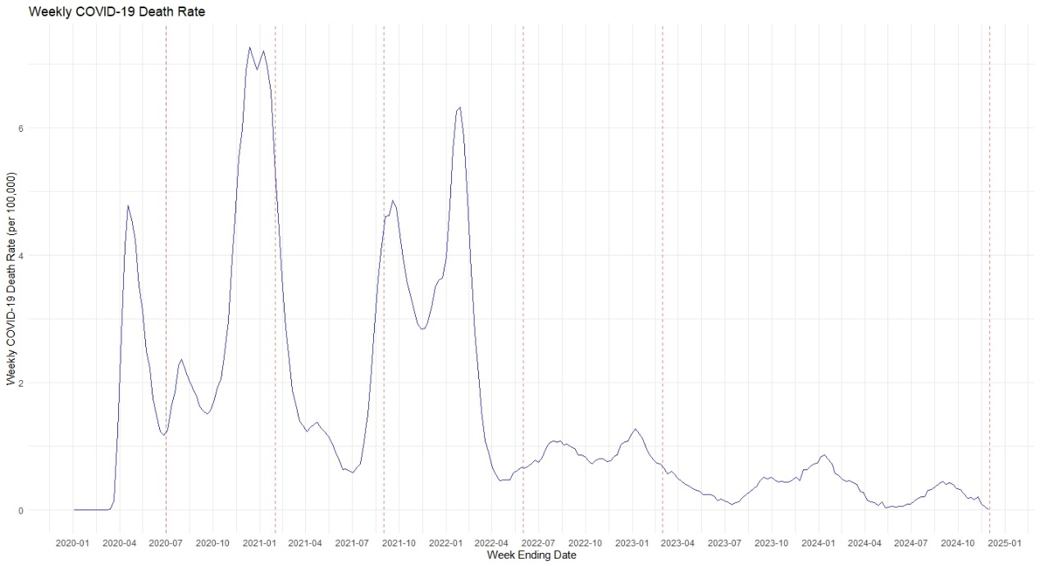
Fig. 2 Pandemic phase division
Based on the visualization of mortality data, the pandemic period from January 2020 to December 2024 has been divided into six phases. Each phase is characterized by a distinct pattern of mortality rates. The first phase, from March 2020 to July 2020, was marked by a rapid increase in the number of deaths, with New York and California experiencing the highest mortality rates. The second phase, from August 2020 to February 2021, saw a rise in deaths again as public health measures were relaxed, particularly in Texas and Florida. The third phase, from March 2021 to September 2021, witnessed a decline in mortality rates due to the widespread availability of vaccines. The fourth phase, from October 2021 to June 2022, was characterized by a sharp increase in deaths due to the emergence of the Delta variant, with Missouri and Arkansas having particularly high mortality rates. The fifth phase, from July 2022 to March 2023, was dominated by the Omicron variant, leading to another surge in deaths, especially in Florida and Texas. The final phase, from April 2023 to December 2024, saw a gradual decrease in mortality rates as vaccination efforts continued and new therapeutics emerged.
To assess the performance of each state during each period, this study calculated mortality rates by state and plotted the average mortality rates for each state during each phase. As shown in Figure 3, this statistical data provides a direct view of how the pandemic spread and changed across different regions, which helps us evaluate the effectiveness of each state's response to the pandemic.
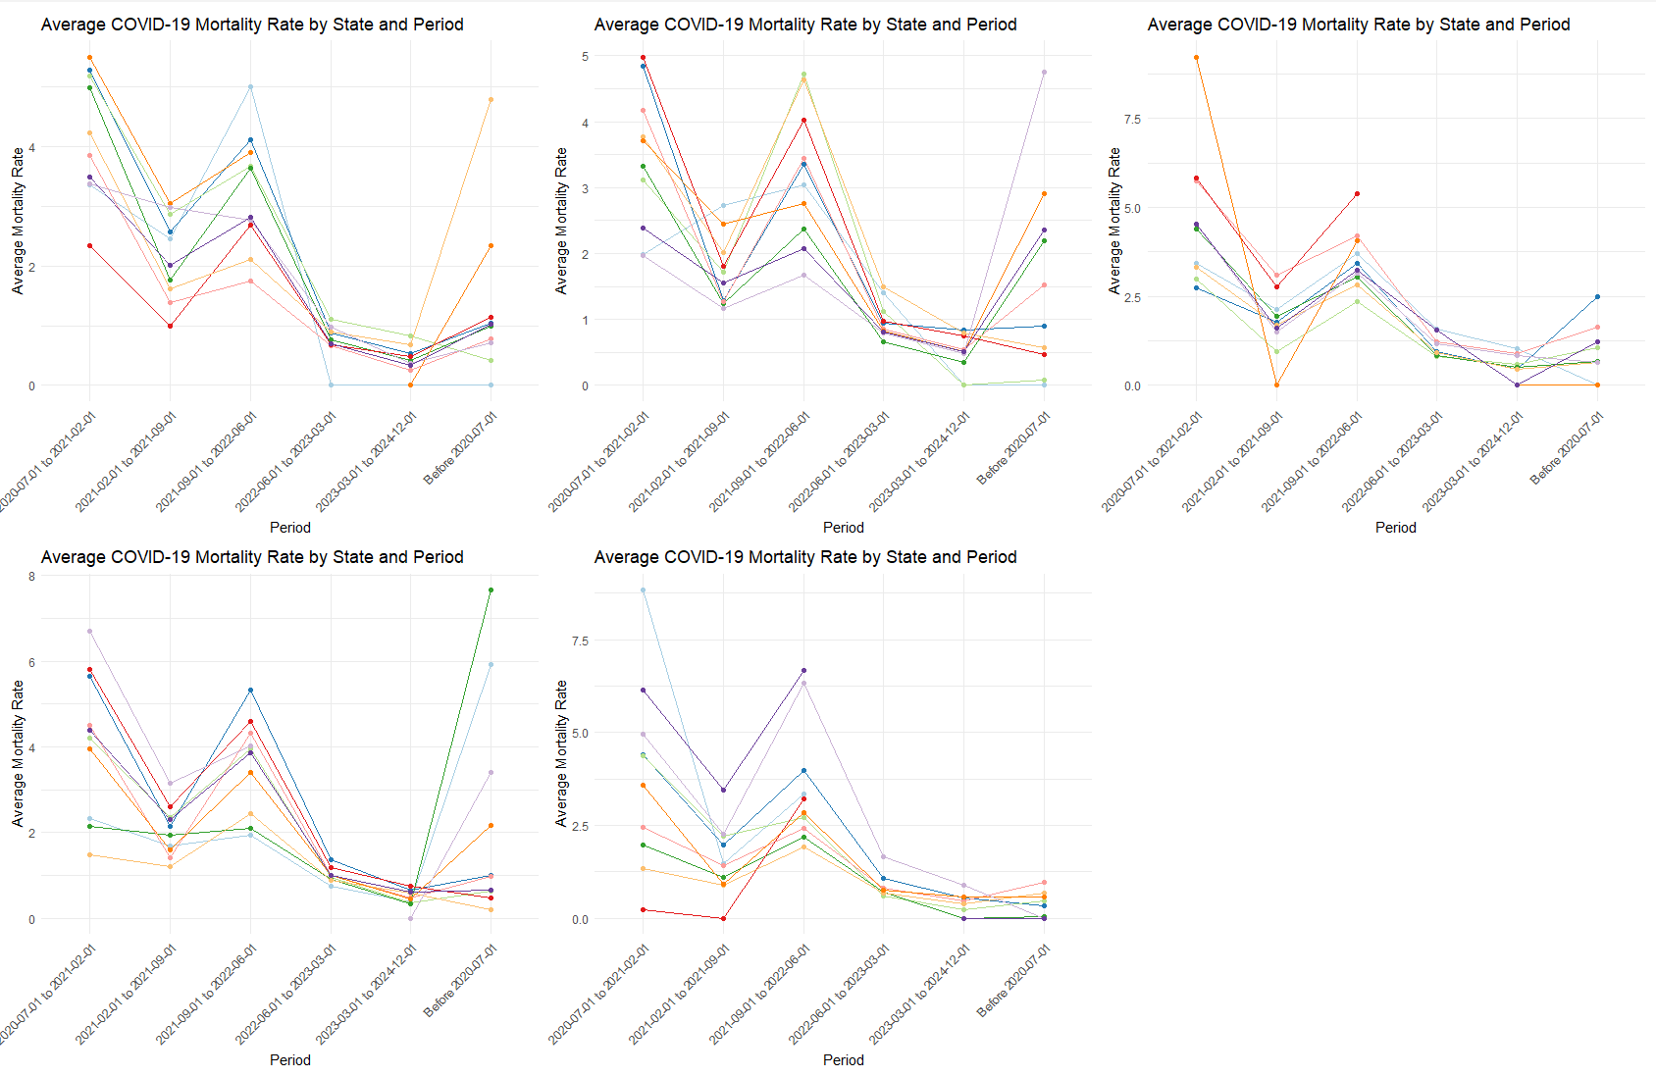
Fig. 3 Average COVID-19 mortality rate by state and period
We conducted an analysis of several typical examples from Figure 3. It can be observed that Alaska has consistently maintained a low average mortality rate. North Dakota had a very low average mortality rate during the initial phase of the outbreak, but it reached the highest average mortality rate of all states during the second phase (when divided by stages), and then it rapidly decreased. New York, on the other hand, experienced the highest mortality rate among the six phases during the very first phase of the pandemic, after which it dropped to a relatively lower value and has not seen a significant increase since. In stark contrast to New York, Florida had an extremely low average mortality rate in the first phase, but it saw an explosive increase in the second phase and has remained high in the subsequent phases.
Furthermore, to provide a more concrete measure of the pandemic's situation in each region, we tallied the number of deaths per state over the course of a week and categorized them according to different phases, which aids in visually assessing the effectiveness of each state's response to the pandemic. The results are depicted in Figure 4.
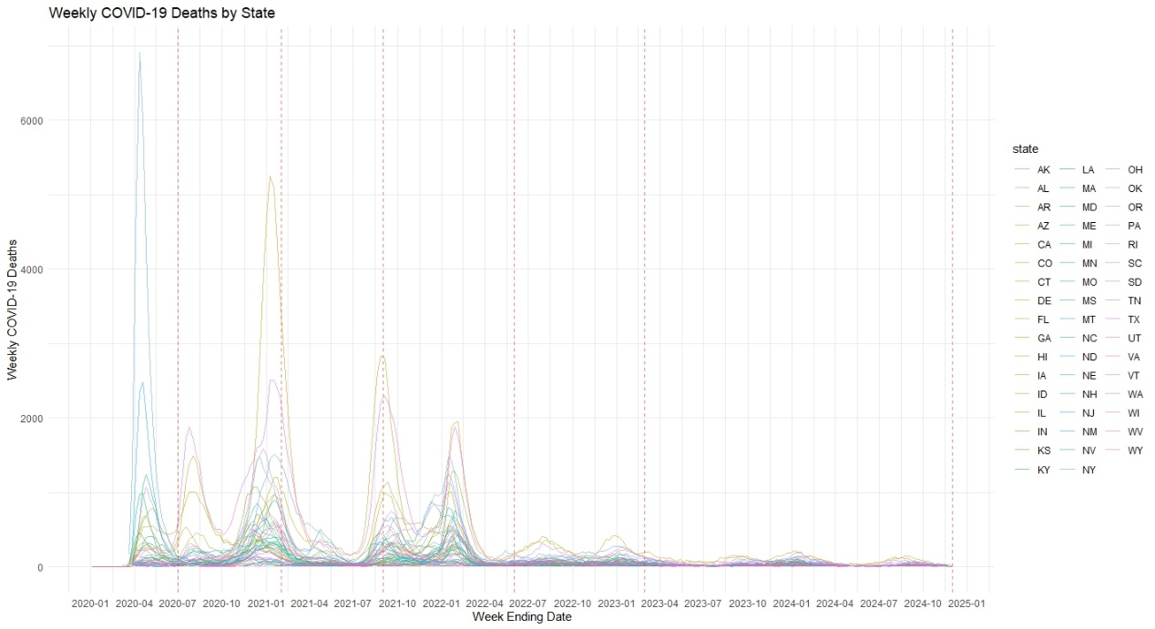
Fig. 4 Weekly COVID-19 deaths by state
During the fourth and fifth phases of COVID-19, the emergence of the Delta and Omicron variants led to an increase in virulence, which can be observed from the sharp rise in the number of deaths, particularly with significantly high mortality rates in states like Missouri and Arkansas.
4 Discussion
This study, by analyzing mortality data during the COVID-19 pandemic, reveals the characteristics of the epidemic's dynamic changes and identifies six phases with distinct mortality patterns. The division of these phases highlights the importance of adjusting public health strategies in response to the virus's evolution. In the third phase, widespread vaccination led to a significant decrease in mortality rates, demonstrating the crucial role of vaccines in mitigating the impact of the pandemic. However, with the emergence of the Delta and Omicron variants, there was a rise in mortality rates during the fourth and fifth phases, emphasizing the need for ongoing surveillance of viral mutations and the development of new vaccines and therapeutic methods^{[7]}. There were significant differences in the performance of states during the pandemic, which can be attributed to a combination of factors including vaccination rates, healthcare infrastructure, and public health policies. States with higher vaccination rates, such as California and New York, more effectively controlled the initial waves of the pandemic, while states with lower vaccination rates, such as Texas and Florida, faced greater challenges in later stages. This indicates that targeted interventions, such as enhancing vaccination campaigns and improving healthcare resources, are essential for addressing regional disparities in pandemic response.
Furthermore, the study found that certain states performed particularly well or poorly during specific phases. For instance, Vermont and Maine maintained low mortality rates throughout the pandemic, likely due to their high vaccination rates and effective public health measures. In contrast, states like Mississippi and Alabama experienced higher mortality rates during the Delta and Omicron waves, suggesting difficulties in implementing effective response strategies in these areas. The study results underscore the importance of adjusting public health strategies to counter the evolution of the virus and the necessity of targeted interventions to address regional differences. By understanding the factors that influence the severity of the pandemic, policymakers and healthcare professionals can develop more effective strategies to mitigate future outbreaks^{[8]}.
This research contributes to a deeper understanding of the complex dynamics of COVID-19 and provides valuable resources for preparing for future health crises. The study also emphasizes the importance of ongoing research to monitor the evolution of the virus and the effectiveness of public health measures. By continuing to analyze data on mortality rates, vaccination coverage, and viral mutations, we can provide evidence-based guidance for future pandemic preparedness. In summary, this study offers key insights into the dynamic nature of COVID-19 and the factors that influence its severity. By understanding the temporal and spatial patterns of the pandemic, we can devise more effective public health strategies and enhance our ability to respond to future health crises^{[9]}. The findings of this study will be a valuable resource for policymakers, healthcare professionals, and researchers, guiding future efforts to protect public health and save lives.
Despite providing valuable insights, the study has its limitations. The research primarily relies on death data, which may not fully reflect the pandemic's impact on public health. Additionally, the determination of pandemic phases is based on visual and statistical methods, which may introduce a degree of subjectivity. Future research could incorporate additional data sources, such as hospitalization rates and vaccination coverage, to provide a more comprehensive analysis^{[10]}.

Reference
[1] J.R. Smith, S. Salven, C.K. Beÿ, S. Thihalolipavan, R. Lev, K.L. Koenig, Opioid-Prescribing Trends in San Diego County, 2008-2019, Journal of Public Health Management and Practice 28(3) (2022) 264-271.
[2] S.M. Kissler, C. Tedijanto, E. Goldstein, Y.H. Grad, M. Lipsitch, Projecting the transmission dynamics of SARS-CoV-2 through the postpandemic period, Science 368(6493) (2020) 860-868.
[3] S.S. Abdool Karim, T. de Oliveira, New SARS-CoV-2 variants—clinical, public health, and vaccine implications, New England Journal of Medicine 384(19) (2021) 1866-1868.
[4] S.M. Moghadas, T.N. Vilches, K. Zhang, C.R. Wells, A. Shoukat, B.H. Singer, L.A. Meyers, K.M. Neuzil, J.M. Langley, M.C. Fitzpatrick, The impact of vaccination on coronavirus disease 2019 (COVID-19) outbreaks in the United States, Clinical Infectious Diseases 73(12) (2021) 2257-2264.
[5] P.M. Lantz, J.S. House, J.M. Lepkowski, D.R. Williams, R.P. Mero, J. Chen, Socioeconomic factors, health behaviors, and mortality: results from a nationally representative prospective study of US adults, Jama 279(21) (1998) 1703-1708.
[6] E.E. Walsh, R.W. Frenck Jr, A.R. Falsey, N. Kitchin, J. Absalon, A. Gurtman, S. Lockhart, K. Neuzil, M.J. Mulligan, R. Bailey, Safety and immunogenicity of two RNA-based Covid-19 vaccine candidates, New England Journal of Medicine 383(25) (2020) 2439-2450.
[7] S. Kashte, A. Gulbake, S.F. El-Amin III, A. Gupta, COVID-19 vaccines: rapid development, implications, challenges and future prospects, Human cell 34(3) (2021) 711-733.
[8] S. Iezadi, K. Gholipour, S. Azami-Aghdash, A. Ghiasi, A. Rezapour, H. Pourasghari, F. Pashazadeh, Effectiveness of non-pharmaceutical public health interventions against COVID-19: A systematic review and meta-analysis, PLoS One 16(11) (2021) e0260371.
[9] S. Badri, V. Sardá, J.S. Moncada, M. Merçon, K. Rezai, R.A. Weinstein, W.E. Trick, Disparities and Temporal Trends in COVID-19 Exposures and Mitigating Behaviors Among Black and Hispanic Adults in an Urban Setting, JAMA Network Open 4(9) (2021) e2125187-e2125187.
[10] J. Hilton, H. Riley, L. Pellis, R. Aziza, S.P.C. Brand, I. K. Kombe, J. Ojal, A. Parisi, M.J. Keeling, D.J. Nokes, R. Manson-Sawko, T. House, A computational framework for modelling infectious disease policy based on age and household structure with applications to the COVID-19 pandemic, PLOS Computational Biology 18(9) (2022) e1010390.
[11] Centers for Disease Control and Prevention (CDC). COVID-19 Data Tracker. 2024. Available from: https://covid.cdc.gov/covid-data-tracker/#trends_totaldeaths_weeklydeathratecrude_00. Accessed December 16, 2024.

